Route Analysis: K.R. Hospital to Udayagiri
This document displays the dynamically routed paths by the Machine Learning Ensemble (Fastest Path — Blue) compared to the standard Dijkstra algorithm (Shortest Path — Red) across 7 distinct environmental and traffic simulations.
The source is K.R. Hospital (~12.3131, 76.6496), marked in Green. The destination is Udayagiri (12.32493, 76.67711), marked in Purple.

1. Ideal Conditions (Clear, Off-Peak)
Under normal off-peak hours with clear weather, the AI quickly confirms the shortest path is generally the fastest path, making minor adjustments only if small traffic waves appear natively. ![Ideal Path](file:///D:/ResQFlow_ML/data/visuals/path_ideal_clear,_off-peak.png)
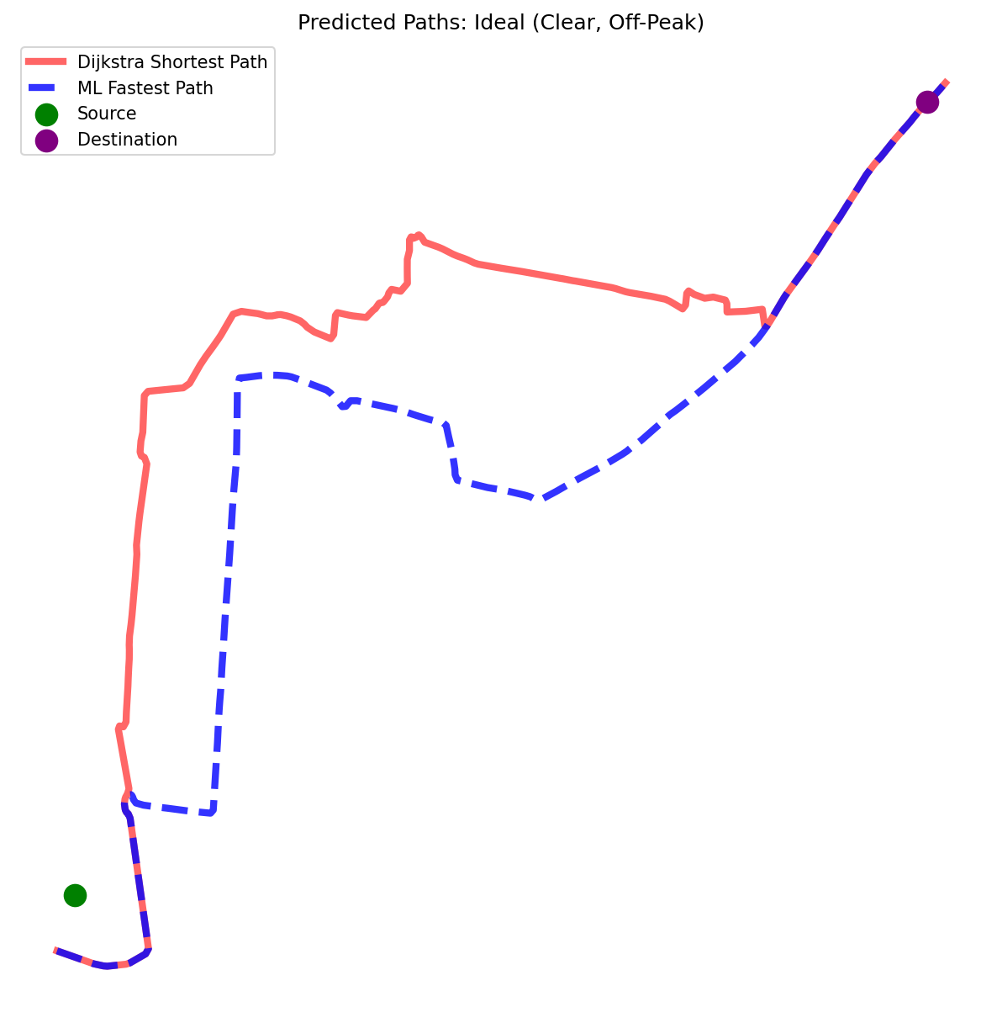

2. Rush Hour (Dense Traffic)
During peak hours, significant volume accumulates on the main arterial roads leading towards Udayagiri. Notice how the ML path significantly diverts from the shortest path line to slice through lesser-known local roads. ![Rush Hour Path](file:///D:/ResQFlow_ML/data/visuals/path_rush_hour.png)
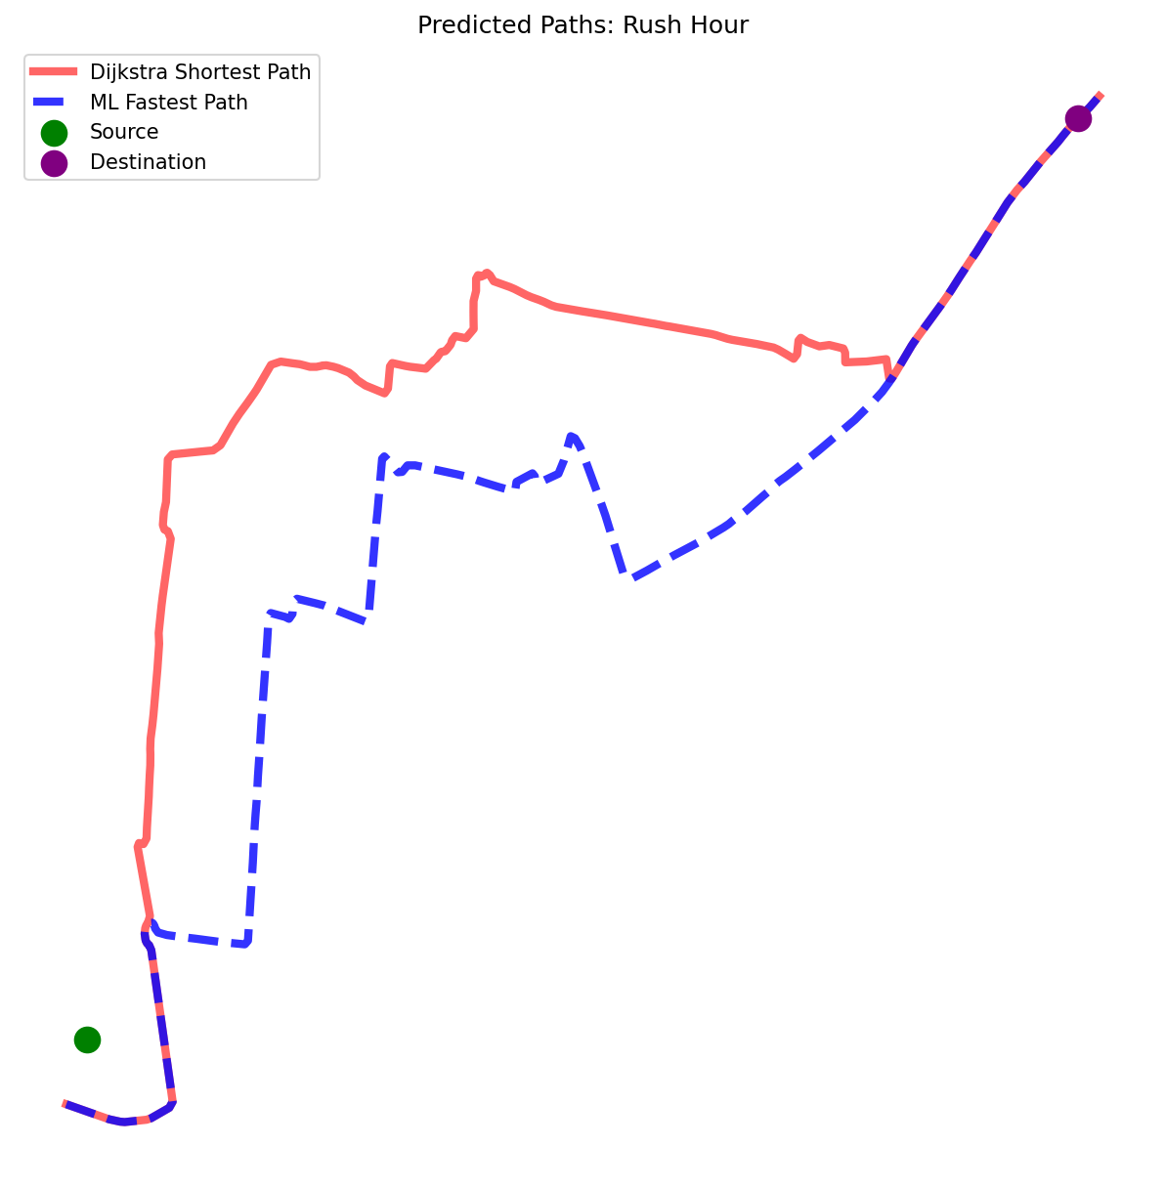

3. Rain (Off-Peak)
Rain forces a global 25% speed limit reduction across the city. ![Rain Off-Peak Path](file:///D:/ResQFlow_ML/data/visuals/path_rain_off-peak.png)
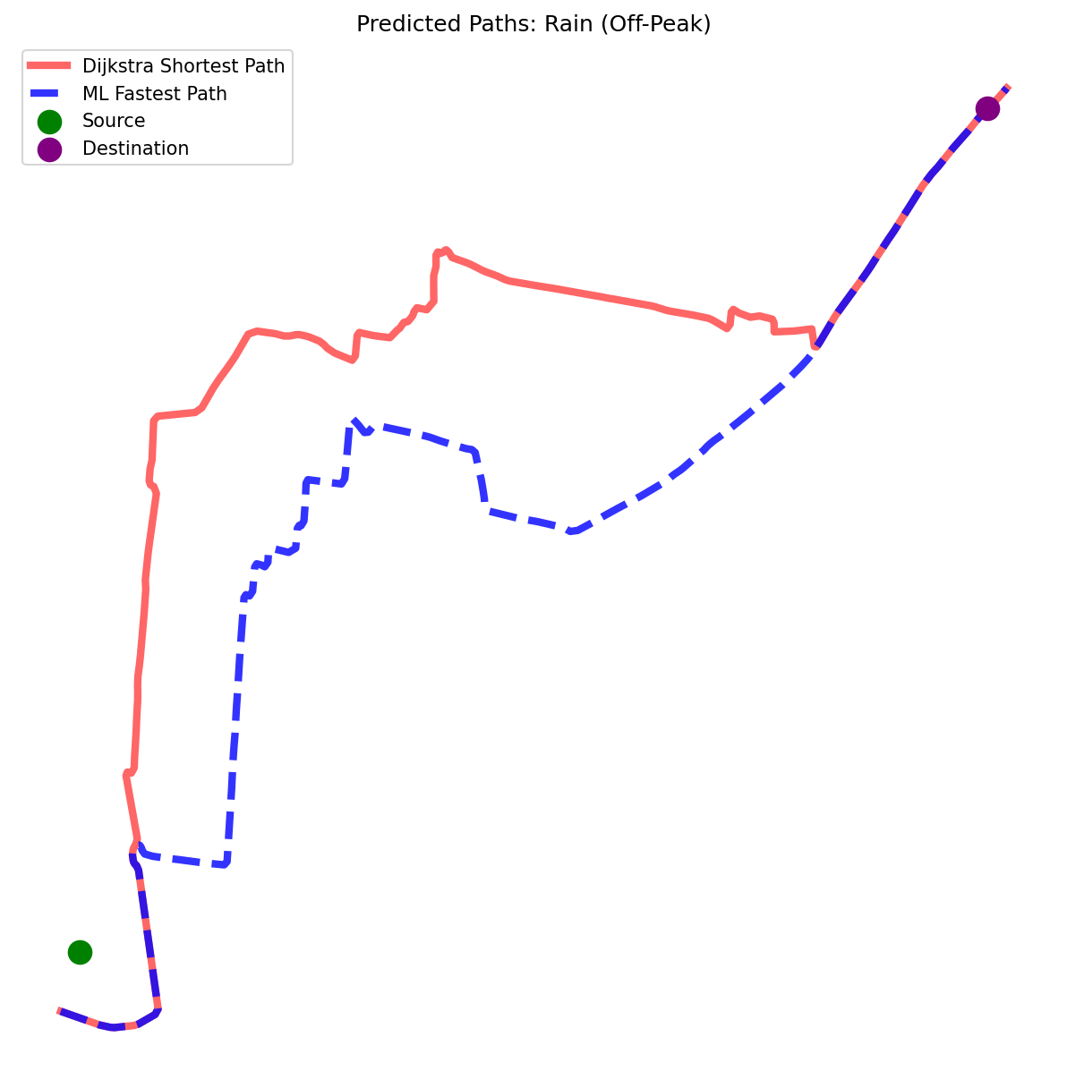

4. Rain + Rush Hour
Combining bad weather with rush hour traffic forces the ML router to take aggressive detours to prevent extreme travel times. ![Rain and Rush Hour Path](file:///D:/ResQFlow_ML/data/visuals/path_rain_plus_rush_hour.png)
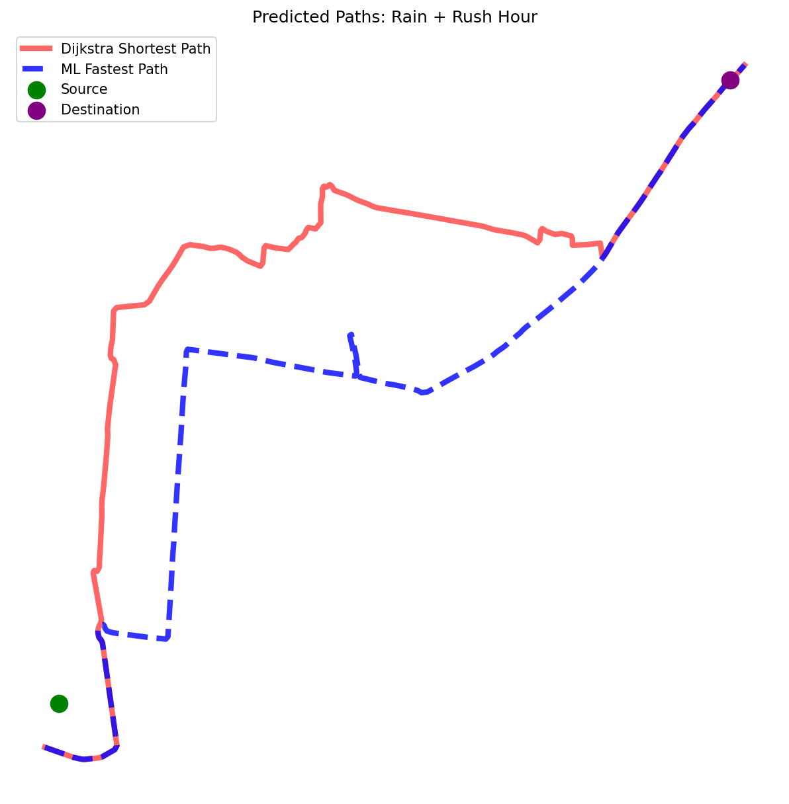

5. Fog + Rush Hour
Fog represents a severe 40% speed drop and artificially longer intersection waiting times due to poor visibility. ![Fog and Rush Hour Path](file:///D:/ResQFlow_ML/data/visuals/path_fog_plus_rush_hour.png)
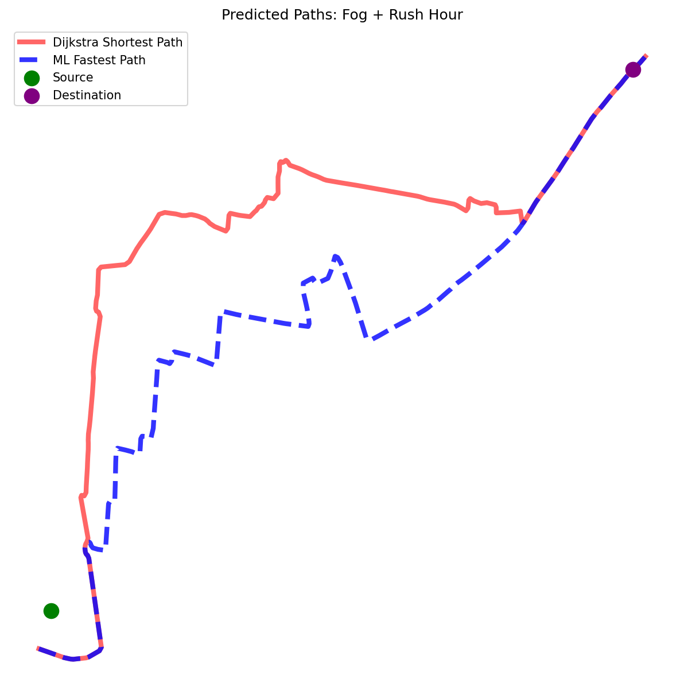

6. Incident: Accident Avoidance (Clear)
A simulated multi-vehicle accident causes a massive 90-second minimum penalty and restricts speed to 50% on certain critical roads. The ML path entirely bypasses the gridlock sectors. ![Accident Avoidance Path](file:///D:/ResQFlow_ML/data/visuals/path_incident_accident_avoidance.png)
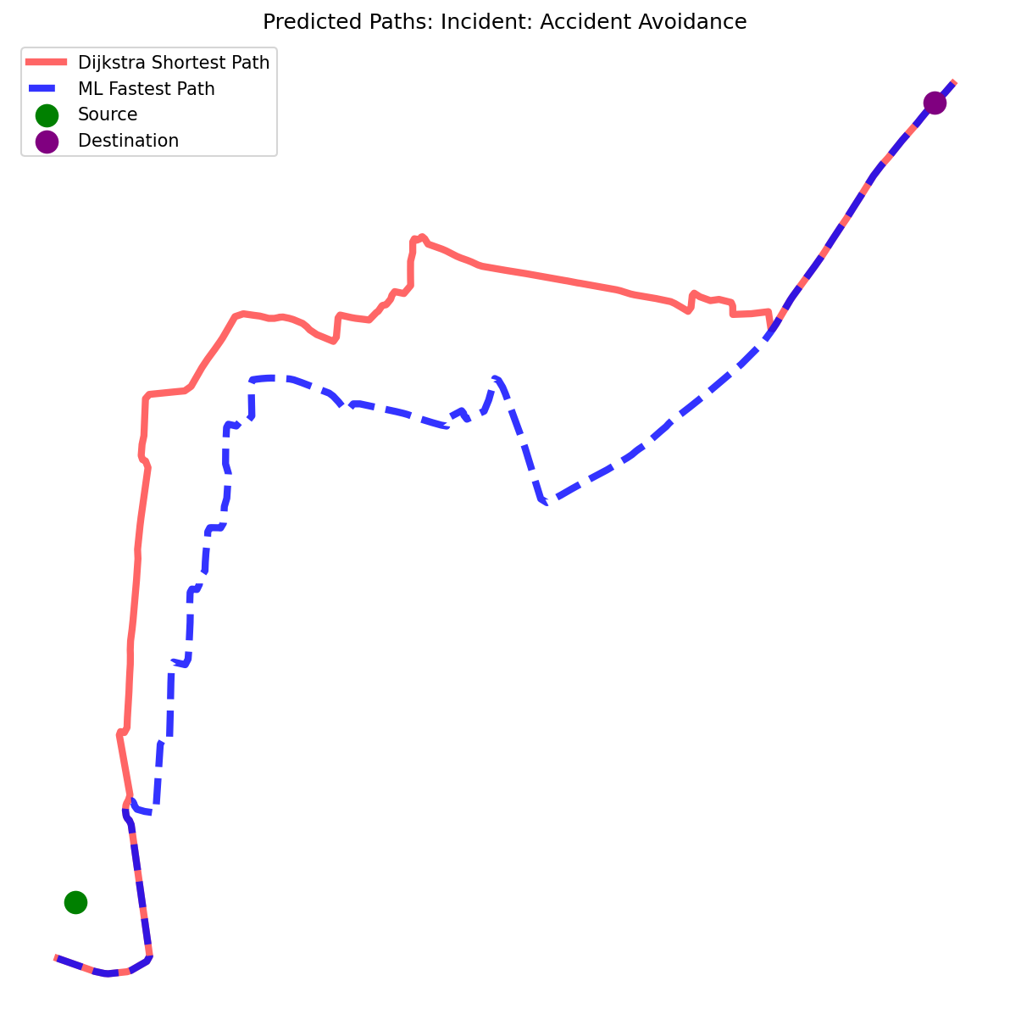

7. Worst Case Simulation (Rain + Rush Hour + Accident)
The ultimate stress test. Simultaneous weather degradation, peak capacity volumes, and an active accident zone. The ML path chooses an unintuitive but significantly faster route around the disaster zones. ![Worst Case Path](file:///D:/ResQFlow_ML/data/visuals/path_worst_case_rainplusrushplusaccident.png)
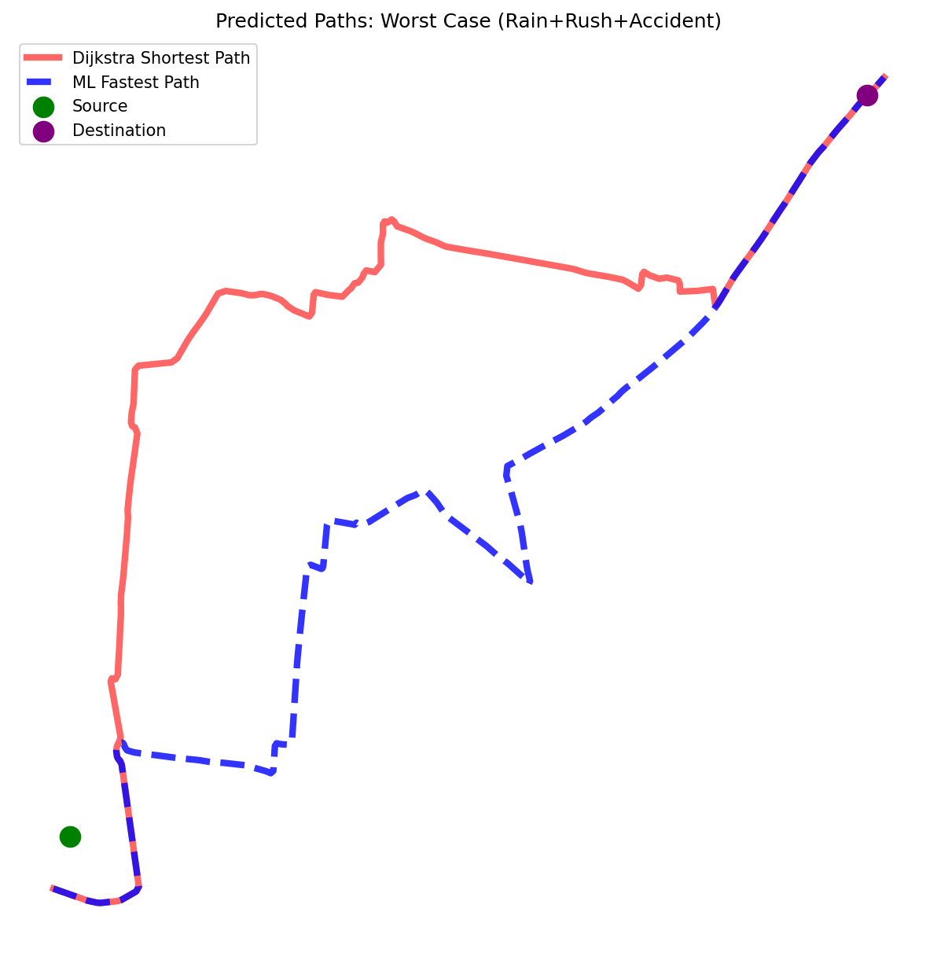

Generated by the ResQFlow Analyzer Script.

